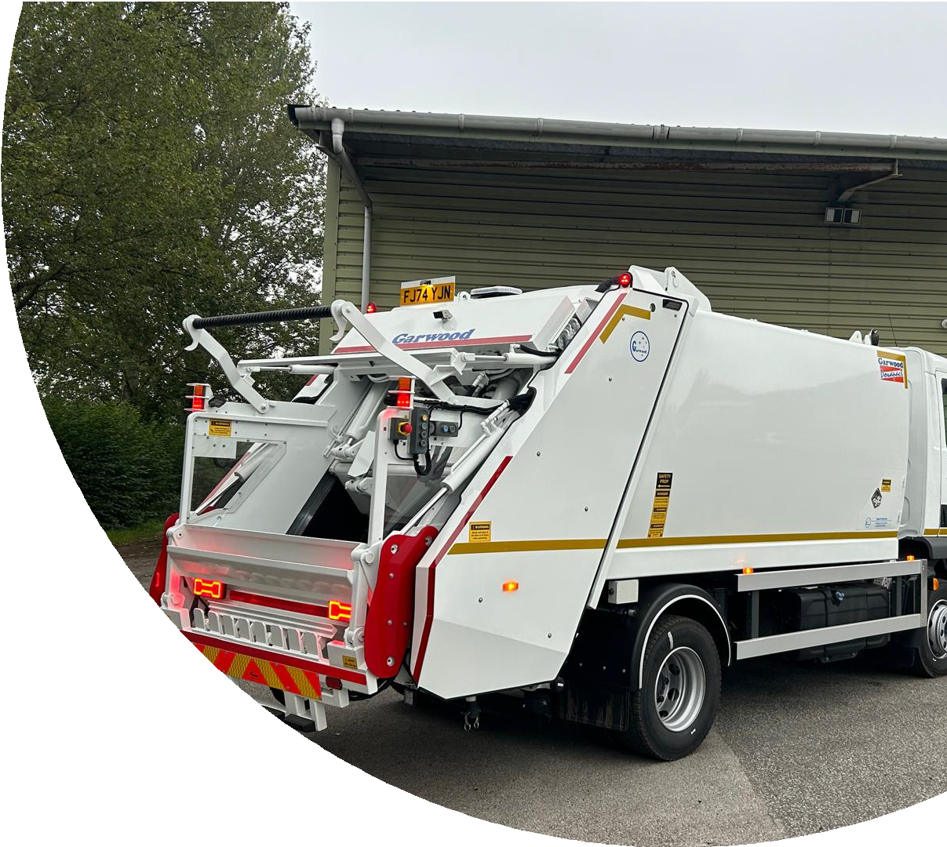
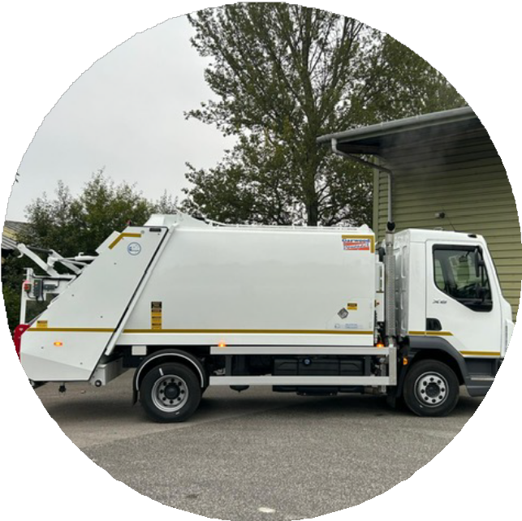

GARWOOD

POWAPACT
A Powerful Packer for Mid Range Chassis.

IDEAL FOR:
Rural Domestic Collection.
Urban Restricted Access Collection. Litter Bin and Recreational Site
Collection.
Recycling, Special and Trade Waste Collections.
The Powapact Range ﬁts chasssis’s 12 tonne to
26 tonne .
High level operating performance delivering fast cycle times at low engine speeds, saving/fuel maintenance costs with low noise and pollution.
Garwood’s own design of truck, with a manual bin lift cable of lifting 120 lt to 1280lt bins including roll top bins, also low hopper allows easy hand loading. Other designs of bin lifts will ﬁt the Powapact.

A selection of body sizes 8m³ - 10m³ - 12m³ - 14m³ - 15m³ - 22m³.
Payloads of approximately 4,500 kg to 11,500kg achieved with bin lift ﬁtted, dependent on chassis.

STANDARD SPECIFICATION

Compact bodywork is available in several body sizes with capacities ranging from 8m3 to 10m3 which are built to compliment the choice of chassis allowing better payloads, greater stability and performance.
Standard bodies are supplied as per the speciﬁcation shown below:

Compact RCV body fully installed and tested Clean body design with smooth sides
Body painted in a single two pack colour Interlocked body side inspection door
Gearbox mounted power take off & hydraulic
pump
Back-Pack prevention system
Electric controls allowing Full or Half pack Tailgate mounted operating controls
including STOP, START, RESCUE, BELL &
BINLIFT controls
Compaction cycle time of 18 to 22 seconds
Front body control station including TAILGATE
RAISE, EJECT, RETRACT & HOPPER CLEAR
Two handed tailgate lower station on off side rear of body
Twin Hopper mounted drain taps
Automatic Tailgate locking
Built in tailgate props for safe working
Polycarbonate tailgate viewing windows
Twin rear tailgate mounted directional LED Beacons
Twin hopper mounted work lights
LED side & rear marker lights
LED high level lights for indicators & tail
lights
LED low level lights including Stop, tail,
indicator, reverse & fog
Standard reverse buzzer
Cab mounted colour rear view camera with 7” TFT heavy duty screen
PTO, Beacons & Work light switches are dash
board mounted using OEM equipment

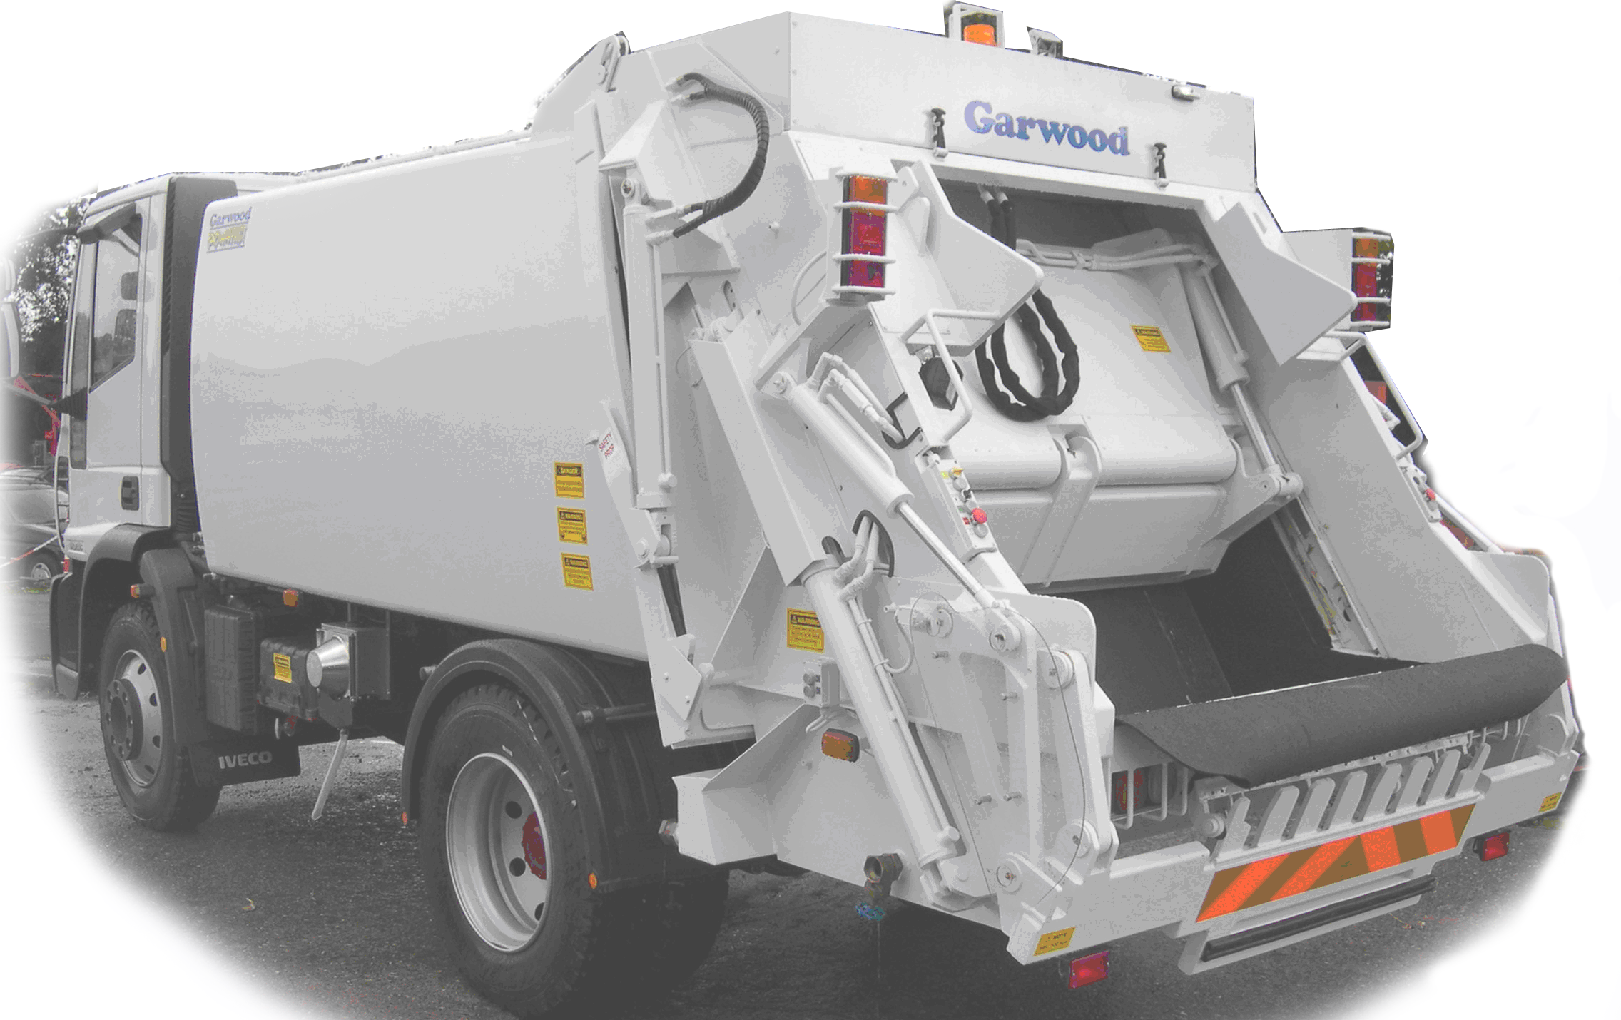
Mudﬂaps



BIN LIFT OPTIONS

Garwood Tuck away wide comb lift to handle EN840-1, 2 & 3 standards
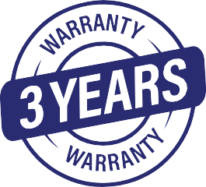
Garwood lifts painted in single two pack colour Nearside and offside binlift push button controls

GENERAL INFORMATION

One year full parts & labour warranty (3 year option available at additional cost)
At the time of Commissioning we will carry out crew familiarisation training Operator and workshop manual provided at the time of commissioning

